

Instructions for Financial Hardship Request

- Follow this link and fill out the form: https://forms.gle/eo7kevQBcJxZivBf6
- Head to our website and click “Sign In” to get to the FYBA TeamSideline.
- Please create your parent user account and add your children as players.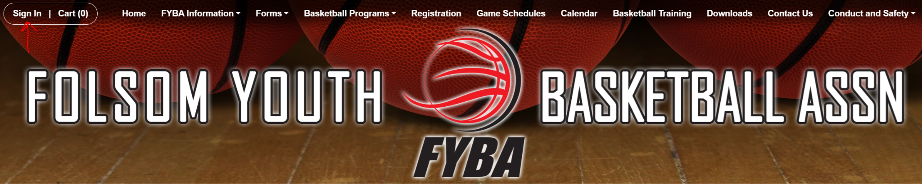
- Once your application is approved, follow the steps to enroll in the current season (you will have a credit on your account, so you will not have to pay)
  - If the credit isn’t there, please reach out to registrar@folsomyouthbasketball.com



